Day-2
Diagnosing Hardware Failures Theory
1. List 5 common hardware issues you might encounter in a desktop PC and write the typical symptom for each (for example: 'No display on monitor' — symptom: blank screen, no POST beep).
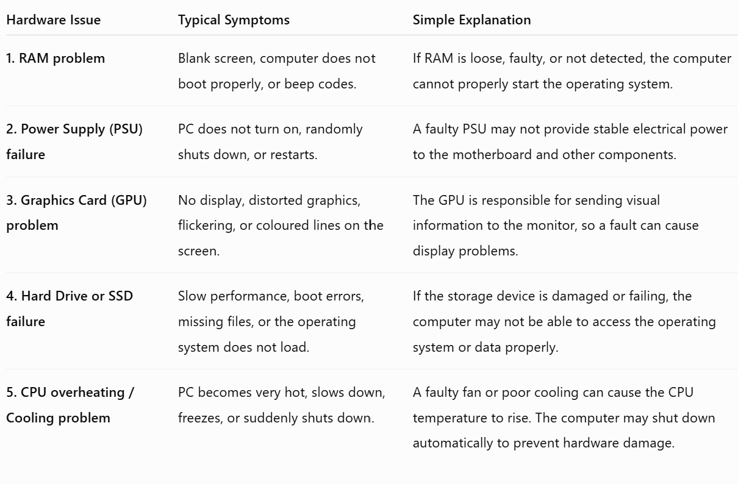
Real-life troubleshooting example
Suppose a desktop computer turns on, but the monitor shows a blank screen. Possible hardware causes include loose RAM, a faulty graphics card, or a monitor connection problem. A technician would check each component step by step to find the exact issue.
Conclusion: Understanding these common symptoms helps a technician identify which hardware component should be checked first during troubleshooting.

2.Given this scenario: A laptop is not charging even when plugged in. Write down a step-by-step troubleshooting plan using only basic tools (no software diagnostics), and explain what you would check at each step.
The following troubleshooting plan uses only basic tools and physical checks, such as visual inspection and a multimeter.
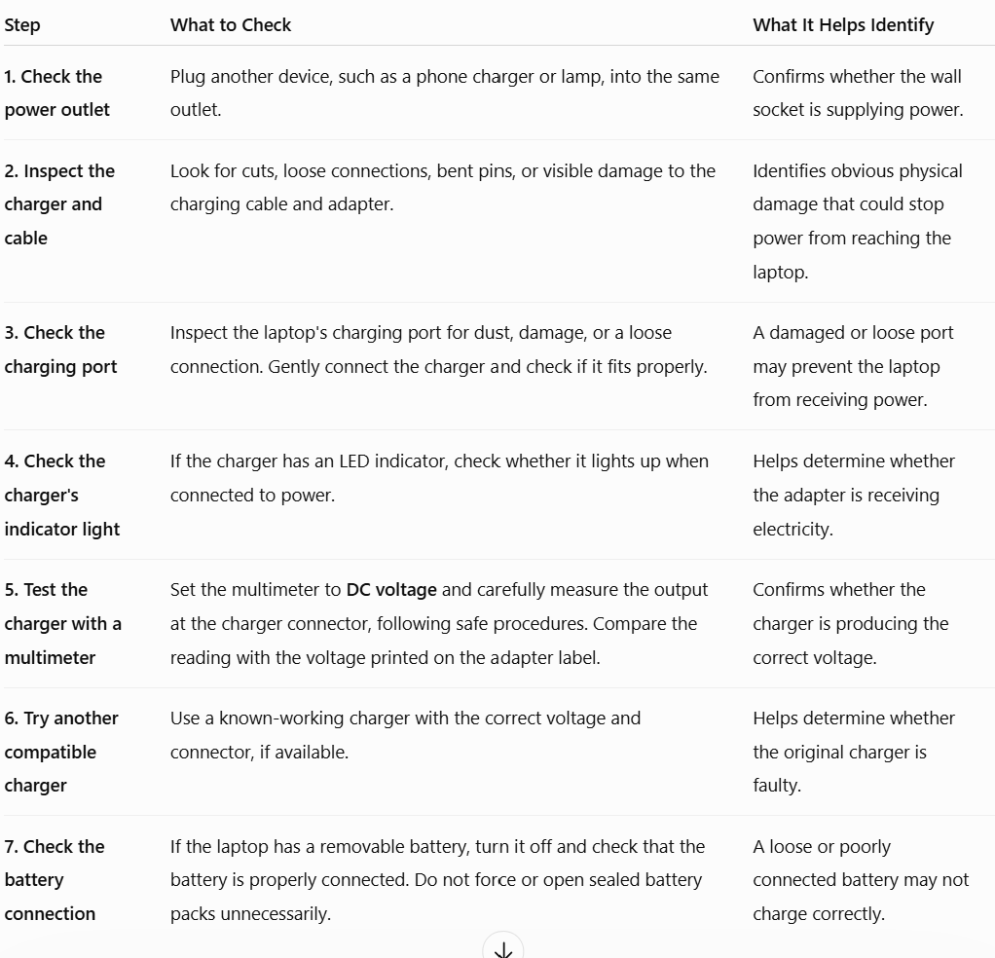
Power outlet → Charger → Cable → Charging port → Charger voltage → Battery connection
Conclusion
If the wall outlet works but the charger does not provide the correct output voltage, the charger or adapter may be faulty. If the charger is working correctly but the laptop still does not charge, the problem could be with the charging port, battery, or internal charging circuit, which may require professional repair.
3.Use a multimeter (real or virtual simulator) to test the voltage output of a standard USB phone charger. Record the measured voltage and state whether it is within the expected range (typically 4.75V to 5.25V for USB).
Objective
To check whether the output voltage of a standard USB phone charger is within the normal USB voltage range of 4.75V to 5.25V.
Equipment Required
- USB phone charger
- Multimeter
Procedure
- A standard USB charger normally provides 5V DC output.
- In an actual test, the multimeter would be set to DC Voltage (V⎓).
- The charger would be connected to a power outlet.
- The red probe would be placed on the positive (+5V) USB contact, and the black probe on the ground (negative) contact.
- The voltage displayed on the multimeter would then be recorded and compared with the expected range.
Sample Result
Expected Voltage Range | Sample Measured Voltage | Result
4.75V – 5.25V | 5.00V DC | Normal ✅
Conclusion
A standard USB charger is expected to provide approximately 5V DC. Using a sample reading of 5.00V, the output falls within the acceptable range of 4.75V to 5.25V. Therefore, the charger output would be considered normal.

4.A PC is randomly shutting down. Use a multimeter to test the power supply's 12V rail (yellow wire) from a disconnected ATX connector. Describe the steps and write down the voltage you find. If the voltage is below 11.5V, what hardware issue could this indicate?
Scenario
A PC is randomly shutting down. One possible cause could be an unstable or faulty power supply unit (PSU). A multimeter can be used to check the voltage of the PSU's 12V rail.
Safety note: PSU testing involves electrical power. Do not open the power supply unit. If you are not comfortable working around powered connectors, ask a qualified technician to perform the test.
Tools Required
- Digital multimeter
- Desktop PC power supply (ATX PSU)
Step-by-Step Procedure
- Turn off the computer and access the ATX power connector safely.
- Set the multimeter to DC Voltage (V⎓) and select an appropriate range above 12V.
- With the PSU operating according to the proper testing procedure, locate a yellow wire, which normally carries +12V, and a black wire, which is ground.
- Place the black multimeter probe on the black (ground) wire/contact.
- Place the red probe on the yellow (+12V) wire/contact.
- Observe and record the voltage shown on the multimeter.
Sample Result
Since this is a sample exercise and no physical multimeter was used, the following is an example reading:
Expected Voltage | Sample Reading | Result
Approximately 12V | 12.08V DC | ✅ Normal
What if the voltage is below 11.5V?
If the measured voltage is below 11.5V, it may indicate that the power supply is faulty or unable to provide stable power. An unstable 12V supply can contribute to problems such as:
- Random computer shutdowns
- Unexpected restarts
- System instability
Conclusion
The PSU's 12V rail can be tested by measuring between a yellow (+12V) wire and a black (ground) wire using a multimeter set to DC voltage. In this sample test, the reading was 12.08V, which is close to the expected 12V output and appears normal. A reading below 11.5V could indicate a weak or faulty power supply, which may contribute to random shutdowns.
sample final answer for your assignment
A PC was randomly shutting down, so the PSU's 12V rail was checked using a multimeter. The multimeter was set to DC voltage, with the black probe placed on a black ground wire and the red probe on a yellow +12V wire. A sample reading of 12.08V was obtained, which is close to the expected 12V and indicates normal operation. If the voltage were below 11.5V, it could indicate a weak or faulty power supply that may cause random shutdowns.

Does a multimeter work for a laptop?
Yes. A multimeter can be used for laptop troubleshooting, but you test different components compared with a desktop PC.
For example, a multimeter can check:
- 🔌 Laptop charger output voltage
- 🔋 Battery voltage (where safely accessible)
- ⚡ Power at the charging port
- 🔧 Continuity of cables or connections

Desktop vs Laptop: What changes?
Tool/Question | Desktop PC | Laptop
Multimeter | Tests the PSU's 12V, 5V, and 3.3V rails. | Tests the charger, battery, and charging port voltages.
POST card | Can be connected to motherboard expansion interfaces, depending on the system. | Less commonly used; laptops often require specialised diagnostic tools.
Software diagnostics | Checks CPU, GPU, RAM, storage, and temperatures. | Checks the same components, plus battery health.
Hardware issues | PSU, GPU, RAM, storage, and cooling problems. | Battery, charger, charging port, RAM, storage, and cooling problems.
Example: Laptop not charging
With a desktop, you might use a multimeter to test the 12V yellow wire from the PSU.
With a laptop, there is usually no ATX connector or yellow 12V wire to test. Instead, you would:
- Check the power outlet.
- Inspect the charger and cable.
- Check the voltage written on the charger label.
- Use a multimeter to measure the charger's output voltage.
- Compare the measured voltage with the value printed on the charger.
Example: If the laptop charger says Output: 19V DC, a reading close to 19V generally indicates that the charger is supplying power correctly.
⚠️ Safety: Laptop motherboards and batteries contain small and sensitive components. Avoid opening the battery pack or probing internal motherboard components unless you have proper training.
Important for your previous answers
Your previous answers are mainly suitable for a desktop PC, especially the question about testing the ATX PSU's yellow 12V wire.
However:
- Answer 1 (common hardware issues): Mostly applicable to both, with some component differences.
- Answer 2 (laptop not charging): Specifically designed for a laptop. ✅
- Answer 3 (USB charger voltage): Works independently of whether you use a laptop or desktop. ✅
- Answer 4 (12V ATX PSU test): Specifically for a desktop PC, not a typical laptop. ⚠️
So, yes, a multimeter works for laptops, but you measure different power sources and components than you would in a desktop.

